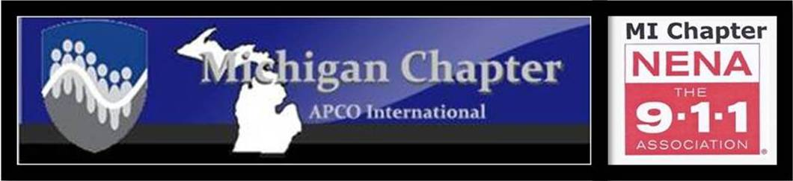
MEETING AGENDA
APCO/NENA JOINT MEETING
Thursday, March 11, 2021
10:00 a.m.
Virtual Meeting

Zoom Information is located on the bottom of the Agenda

Greetings President(s) Collom/Lehman

Pledge of Allegiance President National Anthem
Installation of NENA 2021-2022 Executive Board NENA National Immediate Past President Gary Bell
Approval of Agenda President(s) Collom/Lehman
Introductions 1st Vice Pres Kim Grafton
APCO New Member Report 2nd Vice Pres. Dave Rapacz
APCO minutes Secretary Michelle James
NENA minutes Secretary Samantha Sturgis
APCO Treasurer’s Report Treasurer Phyllis Fuller
NENA Treasurer’s Report Treasurer Tim Jones
APCO President’s Report President Christine Collom
NENA President’s Report President Stephanie Lehman

Presentation: Rapid Deploy Presented by: Greg Brooks
COMMITTEE REPORTS_________________________________________________________________________________
CJIC Update Lisa Hall/Jeremy Ludwig
Training/Membership Activities Kim Ostin/Dave Rapacz/Leah Hornacek
Professional Development Stephanie Lehman
Technical Jeff Kelley
Frequency Coordination/MPSFAC/700MHz Keith Bradshaw/Brent Williams
Pat Coates/Ray Hasil
FirstNet Brent Williams
Joint Michigan Conference Tammy Smith/Christine Collom
APCO National Kim Ostin
APCO Awards Sandra Nielsen
APCO Historical Rich Rybicki
NENA National April Heinze
NENA Legislative Jordyn Sellek
NENA Young HERO Christine Collom
Commercial Larry Stidham/Jim Hansen
State 9-1-1 Committee Rich Feole/Stephanie Lehman
State 9-1-1 Administrator Joni Harvey
MCDA Michael Armitage
Nominating Committee Sandra Nielsen/Phyllis Fuller
****Reminder: Only vote on motions, for the association that you are a member of
(APCO members vote on APCO motions, NENA members vote on NENA motions)
****************************************************************
APCO/NENA OLD BUSINESS

APCO/NENA NEW BUSINESS
- FCC NPRM – Doc 20-291 Christine Collom/Stephanie Lehman
- FCC Ruling (20-100)

APCO OLD BUSINESS Christine Collom

APCO NEW BUSINESS Christine Collom
- National Committee Signup (February 1 through April 1)
- Flash Day- National Conference in San Antonio TX is April 5, 2021

NENA OLD BUSINESS Stephanie Lehman/Tammy Smith
- Executive Board Policy Revision update

NENA NEW BUSINESS Stephanie Lehman
- Pam Opoka-NENA North Central Region Director Candidate Introduction
- Daryl Ostendorf- NENA 2nd Vice President Candidate Introduction

MEETING ADJOURNED
Virtual Meeting Information

Topic: APCO/NENA March Meeting
Time: Mar 11, 2021 10:00 AM Eastern Time (US and Canada)
Join Zoom Meeting
https://us02web.zoom.us/j/83764934508
Meeting ID: 837 6493 4508
One tap mobile
+13017158592,,83764934508# US (Washington DC)
+13126266799,,83764934508# US (Chicago)
Dial by your location
+1 301 715 8592 US (Washington DC)
+1 312 626 6799 US (Chicago)
+1 646 558 8656 US (New York)
+1 253 215 8782 US (Tacoma)
+1 346 248 7799 US (Houston)
+1 669 900 9128 US (San Jose)
Meeting ID: 837 6493 4508
Find your local number: https://us02web.zoom.us/u/keeHZsQDUx
Survey Monkey Link: Please sign-in on the Survey Monkey
https://www.surveymonkey.com/r/March2021Meeting

Please remember to click on the “Participants” tab to vote on motions.

