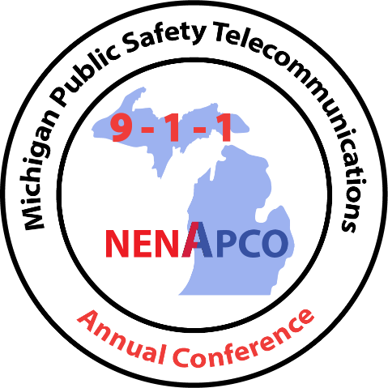

2021

MICHIGAN PUBLIC SAFETY

TELECOMMUNICATIONS CONFERENCE

You asked for it!

2021 Conference!

You now have two more options to attend the 2021 MPSTC!

12:30 Sunday through 4:30 Monday (9 credits)

Or

8:00 a.m. Tuesday through Noon Wednesday (9 credits)

Register today at:

[2021 MPSTC Attendee Registration (regfox.com)](https://michiganpublicsafetytelecommun.regfox.com/2021-mpstc-attendee-registration)