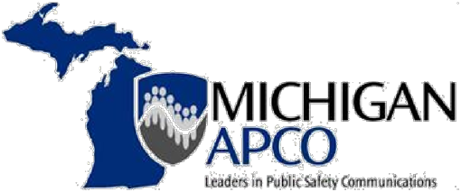

August 13, 2020

Dear Michigan APCO Members,
Michigan APCO and Motorola Solutions have a long standing tradition of coming together annually to celebrate the accomplishments of Michigan 911, industry leaders and inducting the incoming Michigan APCO Executive Board. Unfortunately, this year’s pandemic has changed how we gather and network. The ongoing spread of the virus has challenged all of us and has affected how we conduct our day to day business and membership meetings.
As a Board we have struggled with the decision to break a 60 plus year tradition, but we know as industry leaders a difficult decision has to be made.
After a long conversation and thoughtful consideration, we have decided it is in the best interest for the health and safety of everyone to cancel the annual dinner in Frankenmuth. We are saddened to make this decision and we will miss seeing all of you this year. Please know this was a very difficult decision as this event highlights the best of the best in Michigan 911.
We will host our annual meeting virtually on October 22, 2020 at 2:00 P.M. We will celebrate and recognize the 2020 award winners and install the 2020-2021 Executive Board during this meeting. Specifics on how you can attend this meeting will be sent out in the near future and we hope you will be able to join us.
Please continue to submit your 2020 nominations for the annual awards. We are committed to celebrating the accomplishments of our industry leaders and though it will be different, we feel it is important to recognize those in our industry that have gone above and beyond for their agency and the 911 industry.
Please visit www.miapco.org and join our Facebook page for more information, and chapter updates.

Sincerely,
The Michigan APCO Executive Board

