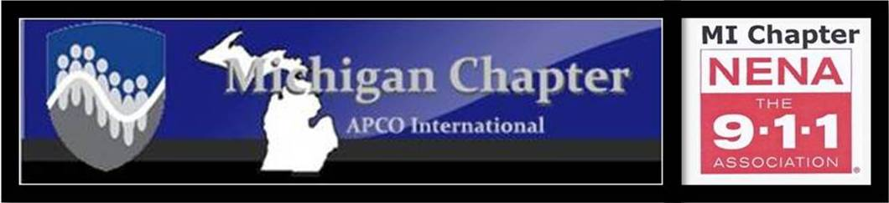

2022
NENA and APCO

MEETING DATES

January 27, 2022 10:00 a.m. Joint meeting
Location: MSP 6th District Headquarters 2290 4 Mile RD. NW, Grand Rapids, MI

March 24, 2022 10:00 a.m. Joint meeting
Location: Barry County 911 NENA Installation of Officers

May 16-May 19 TBD Joint meeting
Location: Kalamazoo Radisson during the Annual Conference

September 15, 2022 10:00 a.m. Joint meeting
Location: Genesee County 911

October 27, 2022 2:00 p.m. APCO
Location: Zehnders in Frankenmuth APCO Annual Dinner and Awards

December 1, 2022 10:00 a.m. Joint meeting
Location: TBD

