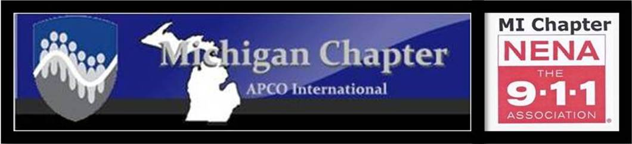

MEETING AGENDA
APCO/NENA JOINT MEETING
Thursday, DECEMBER 2, 2021
10:00 a.m.
OFFERED IN PERSON AND VIA ZOOM
At
Eaton County Central Dispatch
911 Courthouse Dr.
Charlotte, MI 4881

Greetings President(s) Collom/Lehman

Pledge of Allegiance President
Approval of Agenda President(s) Collom/Lehman
Introductions 1st Vice Pres Kim Grafton
APCO New Member Report 2nd Vice Pres. Dave Rapacz
APCO minutes Secretary Michelle James
NENA minutes Secretary Samantha Sturgis
APCO Treasurer’s Report Treasurer Phyllis Fuller
NENA Treasurer’s Report Treasurer Tim Jones
APCO President’s Report President Christine Collom
NENA President’s Report President Stephanie Lehman

Quick Learn: Annual Reports in MiSnap Lyndsay Stephens, SNO
COMMITTEE REPORTS_________________________________________________________________________________
CJIC Update Lisa Hall/Jeremy Ludwig
Training/Membership Activities Kim Ostin/Dave Rapacz/Samantha Sturgis
Professional Development Stephanie Lehman/Kelley Cunningham
Technical Jeff Kelley
Frequency Coordination/MPSFAC/700MHz Keith Bradshaw/Pat Coates/Ray Hasil
FirstNet Kyle Richardson
Joint Michigan Conference Tammy Smith/Christine Collom
APCO National Kim Ostin
APCO Awards Sandra Nielsen
APCO Historical Rich Rybicki
NENA National April Heinze
NENA Legislative Jordyn Sellek
NENA Young HERO Christine Collom
Commercial Larry Stidham/Jim Hansen
State 9-1-1 Committee Lisa Hall/Stephanie Lehman
State 9-1-1 Administrator Joni Harvey
MCDA Michael Armitage
Nominating Committee Sandra Nielsen/Phyllis Fuller

****Reminder: Only vote on motions, for the association that you are a member of
(APCO members vote on APCO motions, NENA members vote on NENA motions)
****************************************************************
APCO/NENA OLD BUSINESS Christine Collom/Stephanie Lehman
9-1-1 Enabling Act Re-write Michael Armitage

APCO/NENA NEW BUSINESS Christine Collom/Stephanie Lehman
2022 Meeting Dates
2021 Conference Update and Budget Report Phyllis Fuller

APCO OLD BUSINESS Christine Collom
911 Goes to Washington Representatives

APCO NEW BUSINESS Christine Collom
APCO Annual Financial Review Phyllis Fuller

NENA OLD BUSINESS Stephanie Lehman
2021 Financial Review

NENA NEW BUSINESS Stephanie Lehman
911 Goes to Washington

MEETING ADJOURNED

Immediately following: Conference Sub-Committee Chair meeting

Next Meeting
In-Person
January 27, 2022 at 10:00 a.m.
MSP 6th District Headquarters
2290 4 Mile Rd NW
Grand Rapids, MI 49544
12/2/2021 Zoom information:
APCO AND NENA ARE inviting you to a scheduled Zoom meeting.
Topic: APCO/NENA Meeting
Time: Dec 2, 2021 10:00 AM Eastern Time (US and Canada)
Join Zoom Meeting
https://us02web.zoom.us/j/87164619221
Meeting ID: 871 6461 9221
One tap mobile
+13126266799,,87164619221# US (Chicago)
+16465588656,,87164619221# US (New York)

Dial by your location
+1 312 626 6799 US (Chicago)
+1 646 558 8656 US (New York)
+1 301 715 8592 US (Washington DC)
+1 346 248 7799 US (Houston)
+1 669 900 9128 US (San Jose)
+1 253 215 8782 US (Tacoma)
Meeting ID: 871 6461 9221
Find your local number: https://us02web.zoom.us/u/kcCbsQkQSZ

