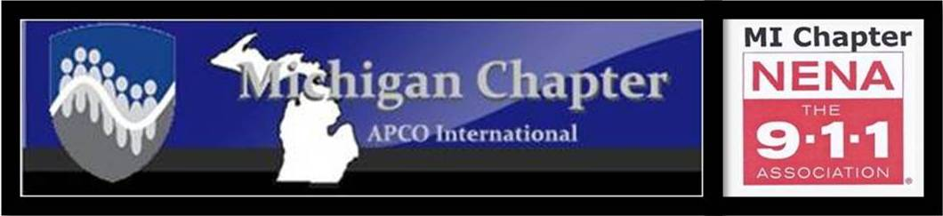
MEETING AGENDA
APCO/NENA JOINT MEETING
Thursday, January 16, 2020
10:00 a.m.
Eaton County Central Dispatch

Greetings Presidents Christine Collom
President Marc Gramlich Pledge of Allegiance President Christine Collom
Approval of Agenda President Christine Collom
Induction of APCO Secretary Immediate Past Pres. Sandra Nielsen
Introductions 1st Vice Pres Terry Vogel
APCO New Member Report 2nd Vice Pres. Dave Rapacz
APCO minutes Secretary Michelle James
NENA minutes Secretary Joni Harvey
APCO Treasurer’s Report Treasurer Phyllis Fuller
NENA Treasurer’s Report Treasurer Tim Jones
APCO President’s Report President Christine Collom
NENA President’s Report President Marc Gramlich
Special Recognition
Induction of APCO Secretary Immediate Past. Pres. Sandra Nielsen

Presentation: State Training Requirements Ms. Theresa Hart, State 911 Office

COMMITTEE REPORTS_________________________________________________________________________________
CJIC Update Lisa Hall/Jeremy Ludwig
Training/Membership Activities Kim Ostin/Tammy Smith
Professional Development Stephanie Lehman
Technical Brad Stoddard
Frequency Coordination/MPSFAC/700MHz Keith Bradshaw/Brent Williams
Pat Coates/Ray Hasil
Joint Michigan Conference Tammy Smith/Christine Collom
APCO National Kim Ostin
APCO Awards Sandra Nielsen
APCO Historical Rich Rybicki
NENA National April Heinze
NENA Public Education Jill Kummer
NENA Legislative Jordyn Sellek
NENA Young HERO Christine Collom
Commercial Larry Stidham/Jim Hansen
State 9-1-1 Committee Rich Feole
State 9-1-1 Administrator Joni Harvey
MCDA Chris Izworski
TIM Dave Rapacz
Nominating Committee Sandra Nielsen/Phyllis Fuller
FirstNet Committee Michael Armitage/Brent Williams

****Reminder: Only vote on motions, for the association that you are a member of
(APCO members vote on APCO motions, NENA members vote on NENA motions)
****************************************************************
APCO/NENA OLD BUSINESS
- 2020 meeting dates amended

APCO/NENA NEW BUSINESS
- 2020 Michigan Public Safety Telecommunicator Conference meeting
Reminder: A Conference Committee meeting is scheduled immediately following the APCO/NENA business meeting.

APCO OLD BUSINESS Christine Collom
- APCO ByLaws
- 2020 APCO Budget Phyllis Fuller

APCO NEW BUSINESS Christine Collom
- 2020 APCO Budget Sandy Nielsen

NENA OLD BUSINESS Marc Gramlich
- By-Law/Policy Review

NENA NEW BUSINESS Marc Gramlich
- Nominations Open for the 2020-2021 Executive Board

MEETING ADJOURNED

The next meeting
APCO/NENA –MARCH 26, 2020
Meeting and Induction of NENA Officers
Livingston County

